I) Run

1. spring-cloud-config-server
2. eurekaserver
3. gatewayserver
4. Security
5. Currency-conversion-service
6. Currency-exchange-service

II) Register user

http://localhost:8081/auth/register

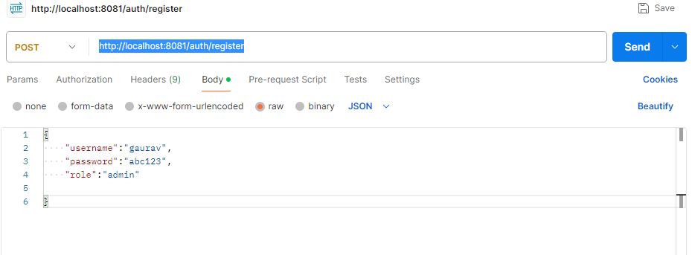

III) Login to generate token

http://localhost:8081/auth/login

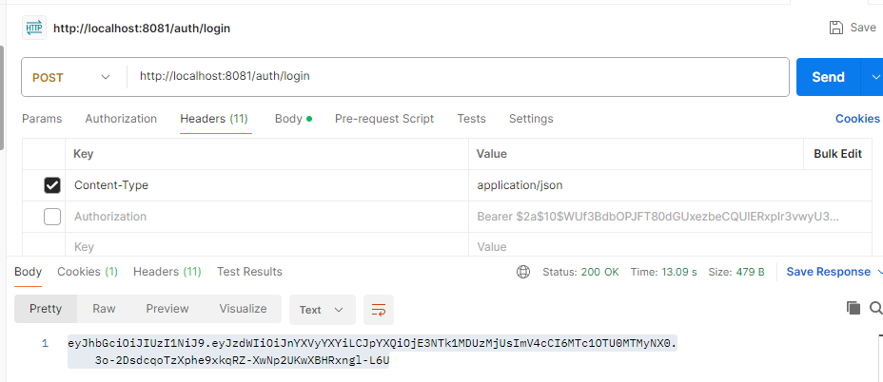

IV) Run app

http://localhost:8091/currency-converter-feign/from/USD/to/INR/quantity/100?Authorization=Bearer $2a$10$WUf3BdbOPJFT80dGUxezbeCQUlERxpIr3vwyU396Ci9IMqg91NHvC

